Back of A Baseball Card

Northeast state

Computer science Ii semester long project

Jonathon Tester

Contents

What Will It Do? 2

How Will It Achieve Its Goals? 2

The Expected Outcomes 2

Deployment Diagram 3

State Machine Diagram 4

API List 4

Project Proposal

# What Will It Do?

The Back of A Baseball Card is a project created in C# with a Graphical User Interface that allows a user to search for any Major League Baseball player and find their current and historical stats.

# How Will It Achieve Its Goals?

Using an API provided by the MLB, the project will fetch the stats and return them for the user. A Graphical User Interface shall be user friendly enough that anyone will be able to use it.

# The Expected Outcomes

With this project, the expected outcome is to have a fully functioning program that allows users to easily search and find their favorite players’ stats.

# Deployment Diagram

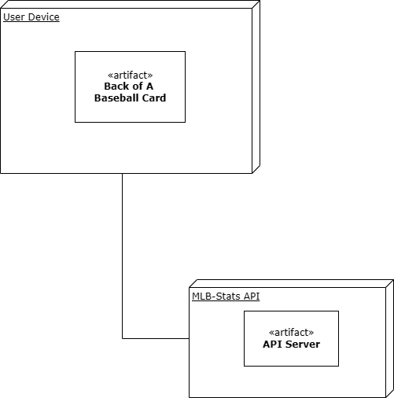

# State Machine Diagram

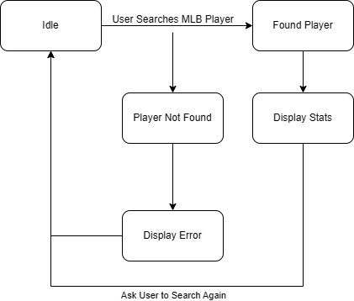

# API List

MLB-Stats API. “https://statsapi.mlb.com/api/”